August 7th, 2017 Infinite Campus System Update:
On the evening of August 7th, Infinite Campus will be updating our system with the latest version. In this version there are several changes in the Campus Instruction area that streamline assignment creation, make the site mobile friendly, and make the overall experience more efficient for teachers.
Some of the changes that you and your teachers will see in the Campus Instruction module include:
- The ability to collapse the index list and give more work space on the screen. Click on the ‘Hamburger’ icon to see how this works.
- To toggle between Campus Instruction, Campus Community or Campus Tools, click on the dropdown list at the top of the index. This replaces the cube icon when in Campus Instruction. The cube icon still exists in the Campus Tool area.
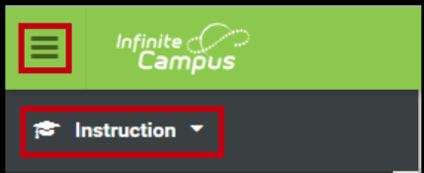
- The main landing page for teachers will be referred to as the Control Center. This page lists all current tasks. Tasks that can be completed from this page include taking the current day’s attendance and scoring assignments.
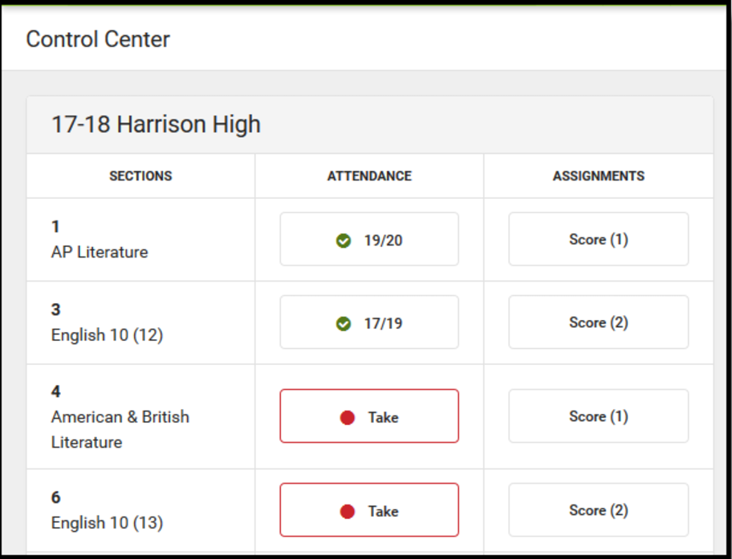
  - The attendance view will look slightly different, but the functionality is the same as before.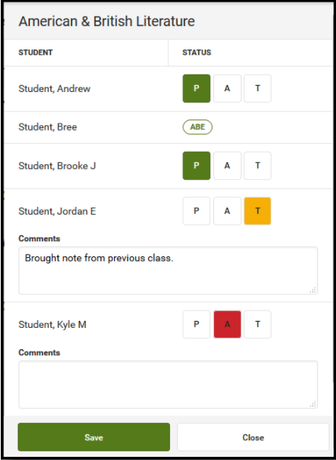
- Creating assignments with have a different look. Infinite Campus has streamlined the process, consolidated the information into an easier-to-view format, and the new editor allows teachers to align an assignment to any section they teach.
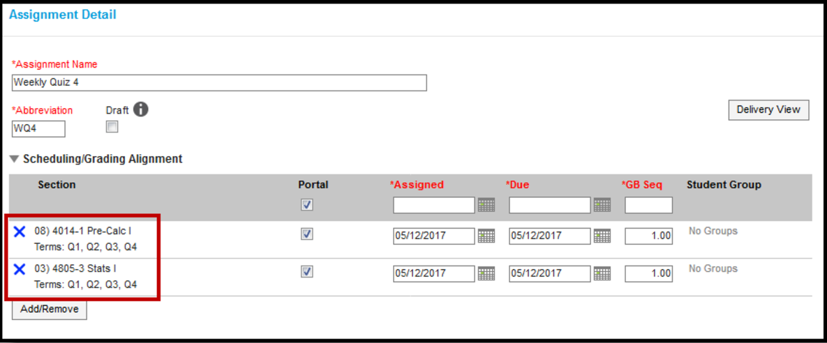
- Additional fields on the assignment editor have been condensed and sorted based on who the information is for: students or teachers.
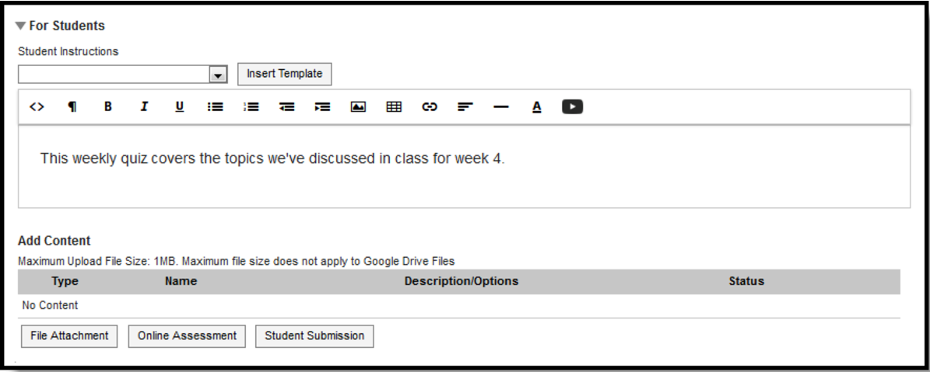
- In For Teachers, teachers can enter other information not viewable by students, including
  - Any applicable Teacher Notes
  - A new option for File Attachments for teachers only, such as an answer key
  - The Unit and Lesson Plan the assignment belongs to
  - Any Curriculum Tags, which are used when searching the Curriculum Library for assignments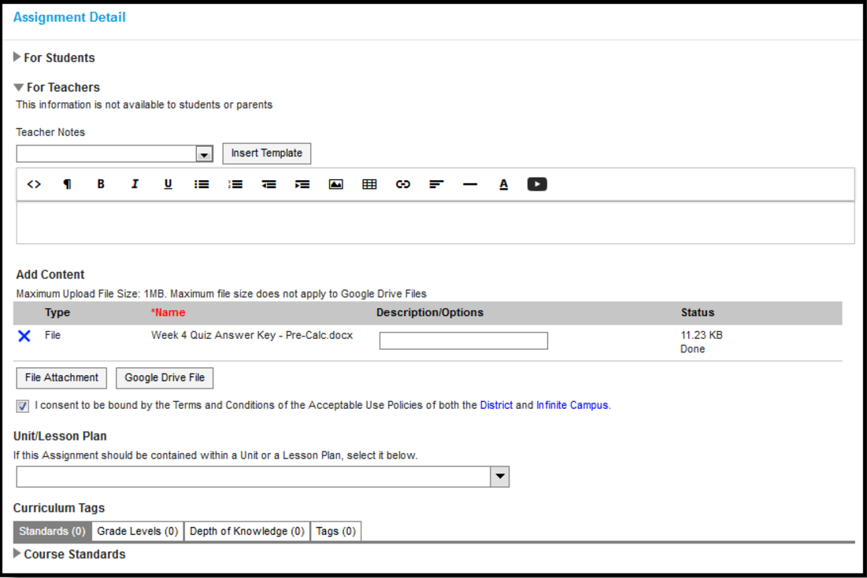

We will send teachers detailed support documents on August 14 to help them navigate the changes to Infinite Campus. Overall, the change are a positive, as navigation within Campus Instruction is slightly more intuitive.

