Proficiency Cut Points (aligned with Smarter Balanced)
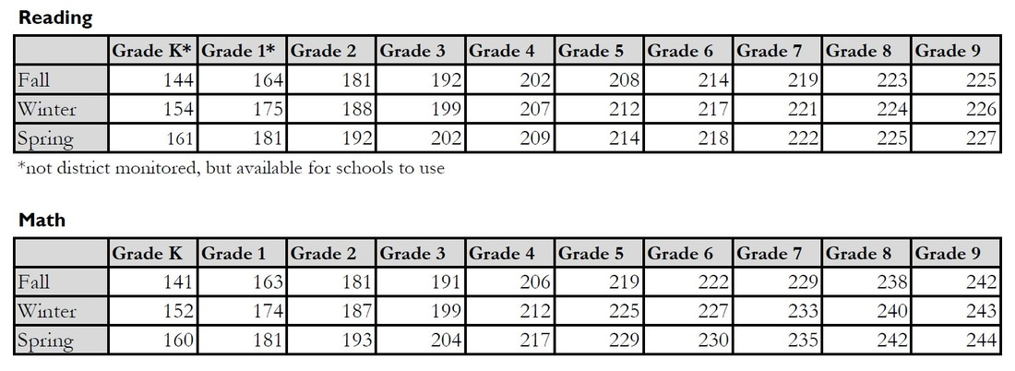
NWEA MAP Norms
